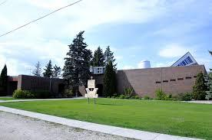 | Trinity Lutheran Church Newsletter
 | October 2025
Contact:  E: tlc118@mymts.net  P: 204-735-2503  tlcstarbuck.com  Address: 43 River Ave Starbuck MB  R0G 2P0 | A Message from Pastor Debra:  I find at this time of the year the people I encounter wondering that we are already through the summer and on the threshold of Thanksgiving. Where does the time go? In thinking of the summer, I expect that somewhere on the way to a cottage or some camp, --- on some eternal car ride someone was singing, ‘The song that never ends,’ or some rendition of that song. ‘The song that never ends’ was written by Norman Martin in 1988 and it became popular as the closing tune on the PBS show ‘Lamb Chops Play Along’ in the early 1990’s. I remember my parents letting us watch Sherri Lewis and Lamb Chop when they appeared on the Ed Sullivan show. I realize I am dating myself but some of you may remember this and know the words.  This is the song that never ends.  Yes, it goes on and on my friends.  Somebody started singing it not knowing what it was  And they’ll continue singing it forever just because.  This is the song that never ends. Etc. etc. etc.  Repeat ad-infinium if you are the singer, ad-nauseam if you happen to be the driver of the car. The song becomes attached to the brain cells so even after the car ride ends, after the lights go off, the words still echo in your mind. I believe each generation has a song like this. For my mother it was, ‘How much is that doggy in the Window.’ For my sister and I it was, ‘10 little angels All dressed in white tried to get to heaven on the end of a kite.’ Each generation has a song like this. The words and tune might be a bit different but the delight it gives to the singer remains the same.  Just like each generation gleans from the one that has gone before it their new song to sing, so this is repeated in the church. In the church we often learn to sing old songs in a new way. For example, Jesus loves me. I learned to sing, ‘Jesus Loves Me this I know, for the Bible Tells Me So.’ with the old traditionally familiar tune. My great nephew sings the same words today with a more upbeat tune. I believe discipleship is like taking an old song and learning to sing it in a new way, in new places.  The story is told in the bible, of an individual who came to Jesus and asked, ‘What must I do to inherit eternal life?’ Jesus answered, ‘Do you know the commandments?’ The response was, ‘O Yes! I know them and I have kept them since I was a child.’ Jesus looked at the person with love and said, ‘There is one thing more that you must do, Go sell all you have and give it to those in need and you will have treasure in heaven.’ At these words the inquirer who owned a lot of property became depressed and went away sad.  I expect that the person asking the question was sincere. I also expect that in listening to Jesus’ teaching, in following for a time, they knew that there was something about him that they wanted. Jesus was inviting them in love, to go a bit further. He was inviting them to join in the song that never ends, the new song that invites and calls us to go deeper into our faith relationship with Christ.  Jesus is always inviting us to take the next step. He is always inviting us to sing the old gospel song in a new way, for a different generation. Jesus invites us to include new friends and create new verses that have never been sung or heard before. Do you ever wonder what happened to this inquiring individual? Do you ever wonder what happened to this faithful  someone? I like to believe that the person came back. I like to believe that the individual didn’t stay away for good.  This Thanksgiving as we give thanks for the many gifts that God gives us, may we also give thanks for God’s infinite presence in our lives and in the lives of those we love. May we ask God to grant us the courage to sing our old gospel songs in this present time, in new and relevant ways.  From my family to yours, HAPPY THANKSGIVING.      Duties and Responsibilities of the Sunday Ushers:  BEFORE THE SERVICE  - Put up the hymn numbers  - Turn off the fan in the sanctuary  - Light the candles on the altar  - Turn on the Lectern Light  - Fold the bulletins  - Hand out the bulletins  - Ring the Bells (Begin ringing the bells 5 minutes before the service. Let them ring between 15 and 20 times  - Take the offering plate to the altar at the time of the offering  - Count the number of people in church.  AFTER THE SERVICE  - Check the number who have joined us online and write it on the calendar provided on the bulletin board.  - Extinguish the candles on the altar  - Put left over bulletins in the recycling bin in the cloak room  - Check the pews for any garbage    Offering Envelopes:  We kindly ask that you please complete the date, name and address portions of each offering envelope used. This is a CRA requirement for all charitable donations. This also helps to make the Sunday morning count run smoothly.  Please also note that all cheques must be made payable to Trinity Lutheran Church. It is not necessary and adds confusion when the word 'Starbuck' is added to this line.  We are deeply grateful for your continued and generous support of the work and ministry of Trinity Lutheran Church.  Treasurer Report:    Income continues to meet budget (-1.5%). Expenses are still significantly lower than budgeted so far as landscaping will take place this fall and sidewalk has been deferred to spring 2026.  Jan - Aug 25 YTD Budget  Total Income $92,793 $94,253  Total Expense $110,321 $148,554  Net Income -$17,528 -$54,301  Readings for October 2025:  October 5, 2025 17th Sunday after Pentecost    First Reading Habakkuk 1:1-4, 2:1-4  Psalm Psalm 37:1-9  Second Reading 2 Timothy 1:1-14  Gospel Reading Luke 17:5-10  October 12, 2025 18th Sunday after Pentecost  First Reading 2 Kings 5:1-3, 7-15c  Psalm Psalm 111  Second Reading 2 Timothy 2:8-15  Gospel Reading Luke 17:11-19  October 19, 2025 19th Sunday after Pentecost  First Reading Genesis 32:22-31  Psalm Psalm 121  Second Reading 2 Timothy 3:14 – 4:5  Gospel Reading Luke 18:1-8  October 26, 2025 Reformation Sunday, 20th Sunday after Pentecost  First Reading Jeremiah 14:7-10, 19-22  Psalm Psalm 84:1-7  Second Reading 2 Timothy 4:6-8, 16-18  Gospel Reading Luke 18:9-14    The Luther Rose  Here is how Luther himself explained the meaning of the Luther Rose:  First, there is a black cross in the heart that remains its natural color. This is to remind me that it is faith in the Crucified One that saves us. Anyone who believes from the heart will be justified (Romans 10:10). It is a black cross, which mortifies and causes pain, but it leaves the heart its natural color. It doesn’t destroy nature, that is to say, it does not kill us but keeps us alive, for the just shall live by faith in the Crucified One (Romans 1:17).  The heart should stand in the middle of a white rose. This is to show that faith gives joy, comfort, and peace—it puts the believer into a white, joyous rose. Faith does not give peace and joy like the world gives (John 14:27). This is why the rose must be white, not red. White is the color of the spirits and angels (cf. Matthew 28:3; John 20:12).  This rose should stand in a sky-blue field, symbolizing that a joyful spirit and faith is a beginning of heavenly, future joy, which begins now, but is grasped in hope, not yet fully revealed.  Around the field of blue is a golden ring to symbolize that blessedness in heaven lasts forever and has no end. Heavenly blessedness is exquisite, beyond all joy and better than any possessions, just as gold is the most valuable and precious metal.  (From: Letter from Martin Luther to Lazarus Spengler, July 8, 1530.    Soup and Prayer:  Once again, this year we will be offering a simple Soup supper with a time for prayer following our meal. It will take place on the first Wednesday of the month from 5:30 pm – 6:45 pm. We will follow the order for Responsive prayer found in your red ELW Worship Book. You will not be expected or required to pray out loud and any sharing is optional.    October Church Cleaning Schedule:  September 29-October 5: Terri M.  October 6-12 Michelle A.  October 13-19: Janis M. & Mel S.  October 20-26: Leah B.  October 27- November 2: Ed & Jane R.  A message from the Editor:  Hello everyone! If ever you have anything you would like included in upcoming newsletters, please email me at: briannahoude@gmail.com :)  -Brianna    Sunday School:  A new Sunday school year began on September 21, 2025 with a special worship service. Grade 3 students Sylvie Broten, Mason Tod and Ronan Zinn received their bibles. More handprints were added to the wall and coffee and cupcakes were enjoyed by all!  There will be no Sunday school on Thanksgiving Sunday, October 12, 2025.  Confirmation Class 2025-2026:  This year our confirmation class will generally be meeting on Thursday afternoons from 12:00 – 12:45 pm. The following individuals will be participating in this year’s class: Mackenzey Manaigre Thornson and Quinn Rasmussen. Please remember Mackenzey and Quinn and their families in your prayers as they continue in their faith journey.    Choir and Handbell Practice:  Please consider joining our church choir and handbell choirs. The choir meets at 7:00 pm on Wednesday evenings and the handbell choir meets at 8:05. Everyone is welcome to join!    Youth Kick-Off Event:  Our very first youth event for the upcoming season is happening October 5, 2025 from 4:00 – 6:00 pm.  Who can come? Grade 5 (age 10) up to age 103. Bring your family, friends, and anyone from the congregation who's ready for a fun evening.  What's happening? We'll kick things off with a Trivia Showdown—test your knowledge, have some laughs, and maybe even learn a thing or two. No team? No problem. We'll form teams once everyone arrives.  After the trivia... We'll share a potluck dinner together. Bring a favourite dish to share.      Questions? Contact Carrie or Brianna. Let's make this a kick-off to remember!  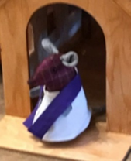  Holy God, as we celebrate Thanksgiving, create in us thankful hearts. May we not take for granted all you have given. In the name of Jesus. Amen  Starbuck and District History Book:  Work is well underway on the Starbuck and District History Book. The committee is continuing to collect family histories, business histories, photos, stories and anecdotes about life in the Starbuck area. We want to include as many families as possible, and we have some great guidelines and samples available if you need help getting started.  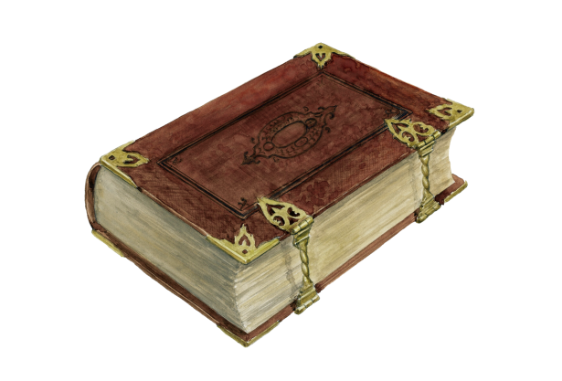  We have an excellent committee working on the project, but we could definitely use more help! If you would like to get involved please get in touch.  For more information please contact:  starbuckhistory@gmail.com  Ron Schade, RR 1, Starbuck Manitoba R0G 2P0 / 204-735-2469  Tammy Shirtliff, RR 1, Starbuck Manitoba R0G 2P0 / 204-792-8170  You can also find us on Facebook at “Starbuck History.”

