October 2025

Canadian Lutheran World Relief Project-Lake Chad:

At our September church council meeting, we voted to respond to the Canadian Lutheran World Reliefs plea to assist in the Friends of Creation Appeal in support of the community around Lake Chad in Africa. Our loose change during the month of October will go to this project. If you have any questions, please contact our church council chairperson Doug Livingston or speak with Pastor Debra.
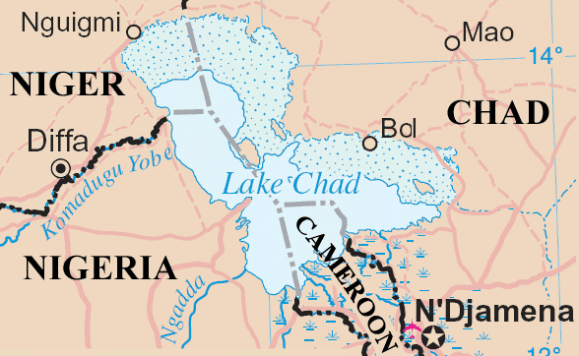

Pumpkin Carving Prayer:

Dear God,
As I carve my pumpkin help me say this prayer:
Open my mind so I can learn about You;
(Cut the top of the pumpkin)
Take away all my sin and forgive me for the wrong things I do. (Clean out the inside)
Open my eyes so Your love I will see;
(Cut the eyes out in heart shapes)
I'm so sorry for turning up my nose to all you've given me.
(Cut a nose in the shape of a cross)
Open my ears so your word I will hear.
(Cut the ears shaped like the Bible)-we did rectangles
Open my mouth so I can tell others You're near
(cut the mouth in the shape of a fish)
Let Your light shine in all I say and do! Amen.
(Place a candle inside and light it)

Bible Study:
This fall beginning on Tuesday, October 21, 2025 at 10:00 am, we will be offering a 5-week Bible study on five of the minor prophets. We will be studying Nahum, Habakkuk, Zephaniah, Haggai and Malachi. Any who are interested in attending are welcome. Each week we will be discussing one of these five minor prophets, so if you aren’t able to attend every week you won’t miss out on anything.

Living Well in the R.M. of Macdonald:

The 2nd Living Well symposium is being held in Oak Bluff! Last year was such a success they have decided to do it again! Tickets are $15.00 and includes a whole day of activities, speakers, booths, door prizes, draws and a delicious lunch! This year the Meridian Council will have a table with items on it displaying their congregational activities. Get your tickets ahead by calling one of the following: Mike or Wendy (Oak Bluff) 204-770-7838, 204-770-2361; Jane (La Salle) 204-227-2975; Nancy (Sanford) 204-471-7056; Ronda (Brunkild) 204-794-4821 or Leanne 204-736-2255.
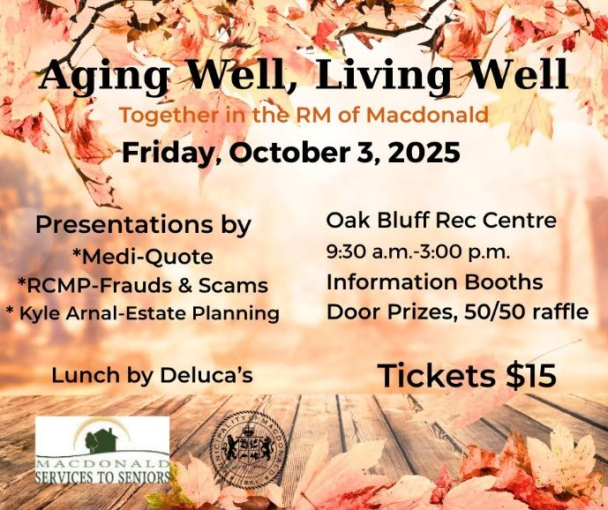

Rev. Dr. Larry Kochendorfer Installed as ELCIC National Bishop:

On Saturday September 27, 2025 members of the ELCIC along with several ecumenical partners from other denominations and faith groups gathered at Faith Lutheran Church in Winnipeg for the Installation Service of the Rev. Dr. Larry Kochendorfer as the ELCIC’s fifth National Bishop.

Among the clergy that were in attendance was Pastor Gordon Hendrickson, Bishop Larry’s confirmation Pastor.
