December 2025

Children’s Advent Worship Service:


Please join us on Sunday December 14, 2025 at 10:00 am for our Sunday school children’s pageant. Each year we look forward to their sharing of the Christmas story with us. This year in addition to the children’s program, we will also be celebrating the baptism of Enzo Michael Fajardo, child of Taylor and Mikhail Fajardo. Please come out and support our children and their teachers and welcome our new baby brother. Stay following the service for refreshments in the parish hall.

Trinity Lutheran -Starbuck United Choir Cantata:

One of the things that we celebrate here at Trinity is our relationship with the Starbuck United Church. For several years now, we have been sharing our worship space. We also share our music ministry. Once again, this year our joint Choir and Handbell choir will offer a Cantata for the Season. It will take place on Sunday, December 21, 2025, at 11:30 am. We encourage you to come out for this special worship service

MERRY CHRISTMAS FROM PASTOR MARTIN MCM
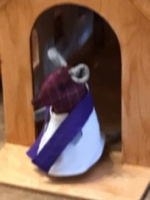
My Christmas Wish for you is:

This Christmas, may your Blessings be Many, your Worries few, and days spent with those who mean the most to you!

2025 Trinity Confirmands:

On Sunday October 26, 2025, four of our young people, Sawyer Nabess, Blake Louttit, Brennan Rasmussen and Kennady Manaigre, made public affirmation of their faith. Please remember them in your prayers as they continue on in their faith journey.
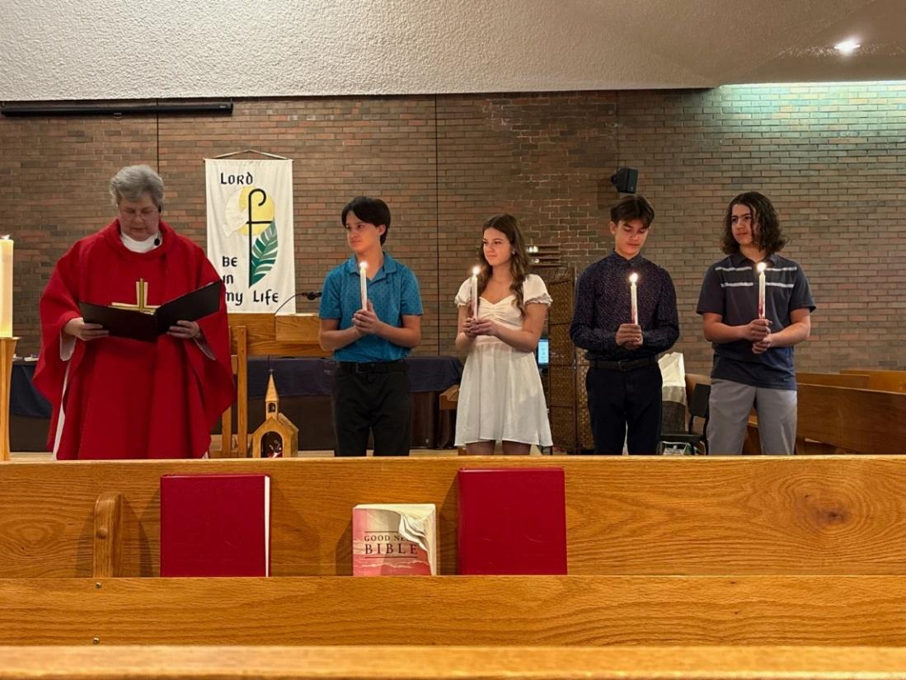

Annual Congregational Meeting:

Our Annual Congregational Meeting will be held on Sunday January 25, 2026 following the Sunday morning worship service and a pot luck lunch in our parish hall.
Please make sure you get your committee and auxiliary reports to Janet Ammeter (Secretary of Church Council) by Friday, January 9, 2026.
It is important that everyone who is able, attend this meeting. We ask for your prayers as we approach this New Year. May God continue to bless us with visions and excitement.

Looking Ahead: Special Events for Advent and Christmas 2025:

Please note once again this year that our Christmas Eve service will be celebrated at 5:00 pm and it will be a Candlelight and Carol service. The Sacrament of Holy Communion will be offered at our Worship service on December 21 Advent 4 and at the 10:00 Christmas Day Service.

November 30, 2025 Advent 1
7:00 pm Meridian Council Advent Worship - Springstein Mennonite Church

December 7, 2025 Advent 2

December 14, 2025 Advent 3
10:00 am Sunday school Pageant Worship service

Sat. Dec. 20 – Thurs. Dec. 25 Church will be open for Silent Prayer

December 21, 2025 Advent 4
10:00 am Lutheran Worship
11:30 am United – Lutheran Church Choir Cantata

December 21, 2024
7:00 pm Lutheran-United On-line Blue Christmas Service

December 24, 2025 Christmas Eve
5:00 pm Candlelight and Carol Service

December 25, 2025 Christmas Day
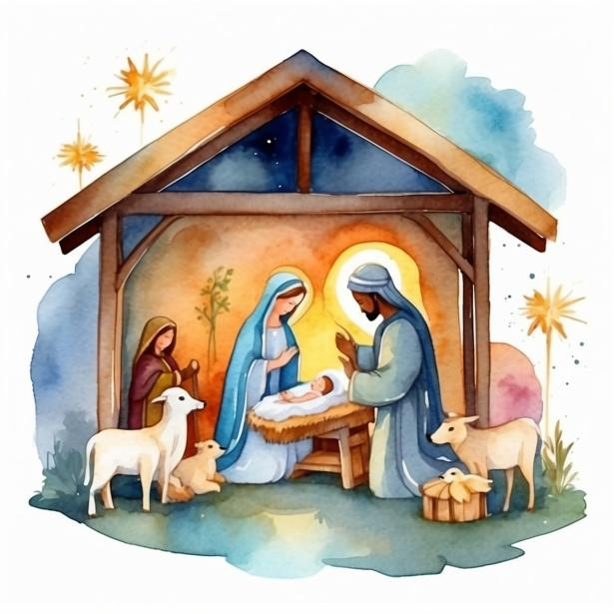
10:00 am Christmas Day Service of Holy Communion

Children’s Advent Colouring Page:
