December 2025


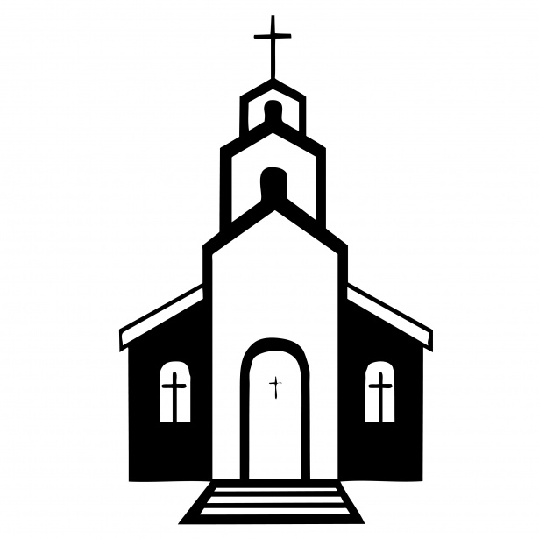
Duties and Responsibilities of the Sunday Ushers:

BEFORE THE SERVICE
- Put up the hymn numbers
- Turn off the fan in the sanctuary
- Light the candles on the altar
- Turn on the Lectern Light
- Fold the bulletins
- Hand out the bulletins
- Ring the Bells (Begin ringing the bells 5 minutes before the service. Let them ring between 15 and 20 times
- Take the offering plate to the altar at the time of the offering
- Count the number of people in church.
AFTER THE SERVICE
- Check the number who have joined us online and write it on the calendar provided on the bulletin board.
- Extinguish the candles on the altar
- Put left over bulletins in the recycling bin in the cloak room
- Check the pews for any garbage


Offering Envelopes:

We kindly ask that you please complete the date, name and address portions of each offering envelope used. This is a CRA requirement for all charitable donations. This also helps to make the Sunday morning count run smoothly.

Please also note that all cheques must be made payable to Trinity Lutheran Church. It is not necessary and adds confusion when the word 'Starbuck' is added to this line.
We are deeply grateful for your continued and generous support of the work and ministry of Trinity Lutheran Church.

Treasurer Report:

As in recent months, income continues to be just slightly below budget while expenses are significantly below with the landscaping and sidewalk deferred to next spring. Overall, the deficit is $30k less than anticipated.


 | Jan -Oct 25 | YTD Budget
Total Income | $114,546 | $117,579
Total Expense | $139,767 | $173,730
Net Income | -$25,221 | -$56,151

Readings for Advent and Christmas 2025:

November 30, 2025 First Sunday of Advent
First Reading Isaiah 2:1-5
Psalm Psalm 122
Second Reading Romans 13:11-14
Gospel Reading Matthew 24:36-44

December 7, 2025 Second Sunday of Advent
First Reading Isaiah 11:1-10
Psalm Psalm 72:1-7, 18-19
Second Reading Romans 15:4-13
Gospel Reading Matthew 3:1-12

December 14, 2025 Third Sunday of Advent
Gospel Reading Luke 2:8-20


December 21, 2025 Fourth Sunday of Advent
First Reading Isaiah 7:10-16
Psalm Hymn
Second Reading Romans 1:1-7
Gospel Reading Matthew 1:18-25

December 21, 2025 United – Lutheran Cantata
Reading Isaiah 35:1-8a
Reading Luke 1:26-33
Reading Luke 1:34-35
Reading Luke 1:39-45
Reading Matthew 1:18–23
Reading Luke 2:8-14

December 24, 2025 Christmas Eve
The Isaiah Prophesy Isaiah 9:2, 6-7
The Bethlehem Prophesy Micah 5:2-5a
The Birth of Jesus Luke 2:1-7
Announcement to the Shepherds Luke 2:8-14
The Shepherds Visit Luke 2:15-20

December 25, 2025 Christmas Day
First Reading Isaiah 52:7-10
Psalm Hymn
Second Reading Hebrews 1:1-4
Gospel Reading John 1:1-14
December 28, 2025 First Sunday of Christmas
First Reading Isaiah 63:7-9
Psalm Psalm 148
Second Reading Hebrews 2:10-18
Gospel Reading Matthew 2:13-23


December Church Cleaning Schedule:

December 1-7: Andy & Sherri M.
December 8-14: Don & Mona Q.
December 15-21: Ron & Gwen R.
December 22-28: Daphne G.

Message from the Editor:
Hello everyone! If ever you have anything you would like included in upcoming newsletters, please email me at: briannahoude@gmail.com :)
From my family to yours, I wish you a very Merry Christmas and a healthy and Happy New Year!
-Brianna


Westwood Community Band Christmas Concert:

Westwood Community Band Christmas Concert will take
place at the Starbuck Community Hall on Thursday
December 11 at 7:30 pm. Everyone is Welcome.

Worship Schedule for Advent and Christmas 2025:

November 30, 2025 Advent 1 10:00 am Service of the Word (Trinity)
7:00 pm Meridian Council Advent Service (Springstein)

December 7, 2025 Advent 2 7:00 pm Service of Holy Communion

December 14, 2025 Advent 3 10:00 am Holy Baptism and Children’s Pageant

Sat. Dec. 20 – Wed. Dec. 25 Church will be open for Silent Prayer

December 21, 2025 Advent 4 10:00 am Lutheran Worship of Holy Communion
11:30 am United – Lutheran Choir Cantata
7:00 pm Lutheran-United Blue Christmas Service (Online)

December 24, 2025 Christmas Eve 5:00 pm Candlelight and Carol Service

December 25, 2025 Christmas Day 10:00 am Christmas Day Service of Holy Communion


Blue - Longest Night Worship Service:

Please join us at 7:00 pm on Saturday December 21, 2025 for a special ZOOM Blue Christmas Service.
A Blue Christmas service is a service which recognizes that the holidays are sometimes ‘blue’, or filled with difficult feelings around painful life events such as death, illness, poverty, and all manner of loss. This service is also called ‘The Longest Night’. In our Western Christian tradition, it is a day in the season of Advent which marks the longest night of the year.

This night allows us to verbally acknowledge the griefs and pains in our lives that impact our celebrations. It is a reminder to us that our Creator God loves us to the point of emptying himself of his divinity in order to take on our humanity. God entered our world as a tiny baby, lived, worked and died for us, so that we would know, among other things, that there was nothing we would ever experience, that God in Christ had also not experienced. God came to us as God did by humble means so that we would know that he was accessible to everyone. I encourage you, as you are able to attend this special service. Blessings to each of you!

