40th Anniversary of the ELCIC 1986-2026:

This year marks 40 years in the life of our church! This milestone not only invites us to remember our story, but also to reflect on who we are today and how God is calling us forward as a church Living out God's grace and unconditional love.


One of the key moments as we celebrate this milestone will be the ELCIC Day of Action on May 31. On that day, you and your congregation are invited to join with congregations across the ELCIC in stepping beyond your church walls and engaging in acts of service in your community. Watch here, on social media and on the ELCIC website for further details which will be available soon!
40th Anniversary of the ELCIC
1986 - 2026

Behind the Scenes at Trinity Lutheran Church:

As you know, there are many people who do many different jobs in our congregation both through the week and also on a Sunday morning. Each of these jobs are important and help to aid in the easy worship of our God.
The ushers in our congregation have an important job. They not only, fold and hand out our weekly bulletins and welcome people as they arrive, they also do many other things. For example, the put the hymn numbers up on our hymn board. They turn off and on the fan. They ring the bells. An important task they have is lighting the candles on our altar. This like many things is often not as easy as it looks. Below are the instructions they follow.

Lighting of Wax Tapers
- Extend lighting taper 1 inch out from candle lighter before lighting.

- When lighting the candles do not touch candle wick or follower with the lighter. Handle lighter carefully to avoid pieces of taper or wick from breaking off and falling into the candle cup. These broken off pieces may act as a second wick, creating a double flame resulting in candle failure.

- After extinguishing taper flame by retracting into candle light tube, immediately extend taper out from the tube to avoid wax build-up and jamming. Inspect to ensure taper is completely extinguished.

Extinguishing
- Always use a candle extinguisher to put out candle flame. Never blow out candle. To extinguish, gently place extinguisher over candle follower, being very careful not to touch either the wick or follow. The follower is resting on both liquid and soft wax, tilting it or compressing it with the extinguisher may cause the candle to malfunction the next time it is used.

- To avoid afterglow always allow a candle to burn at least 2 minutes before extinguishing. Afterglow may cause a wick to shorten itself making it difficult to relight.

We hope you have enjoyed our first ‘behind the scenes’ look. Stay tuned for next month for another ‘behind the scenes’ adventure.


New Church Cushions- a softened situation!
Good news for those who've been quietly (or not so quietly) enduring the steadfast firmness of our pews: relief has arrived!
After careful consideration—and what we can only assume were several very persuasive shifts, wiggles, and discreet mid-sermon posture adjustments—we are pleased to announce that four seat cushions have officially been purchased.
These cushions are now available for anyone who finds the benches a little too enthusiastic in their support of... well... your bones.
We like to think of this as a small, but meaningful step toward greater comfort during worship—because while we aim to lift spirits, we no longer feel it necessary to test endurance at the same time.
Please feel free to make use of the cushions as needed.

Your Property Committee

The Urban Schedule 2026:
- Thursday, April 30
- Thursday, May 28
- Thursday, June 25
Urban closed in July
- Thursday, Aug. 27
- Thursday, Sept. 24
- Thursday, Oct. 23
- Thursday, Nov. 26
- Monday, Dec. 21

2026 Meridian Arts Festival - Celebrating 33 Years:

The 2026 Meridian Arts Festival will take place in Starbuck and area from April 13-20, 2026
The coordinator for this event is Patsy Andrews-Vert and the Adjudicator for all disciplines will be Maureen Baird, from Melita MB
The dates that participants will be playing at Trinity is still to be determined.
Many of our youth and children, as well as our choir and Handbell choir participate in this event. You are encouraged to drop in whenever possible as a support to our members.


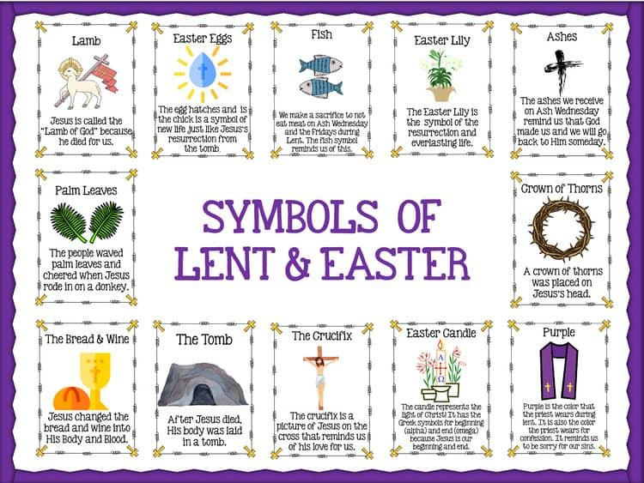

Meridian Inter-Church Council Anniversary:

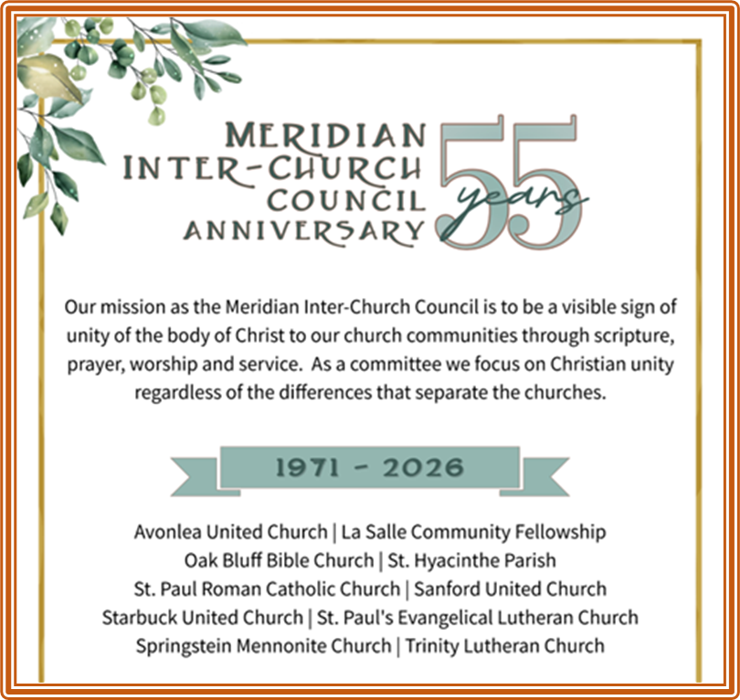

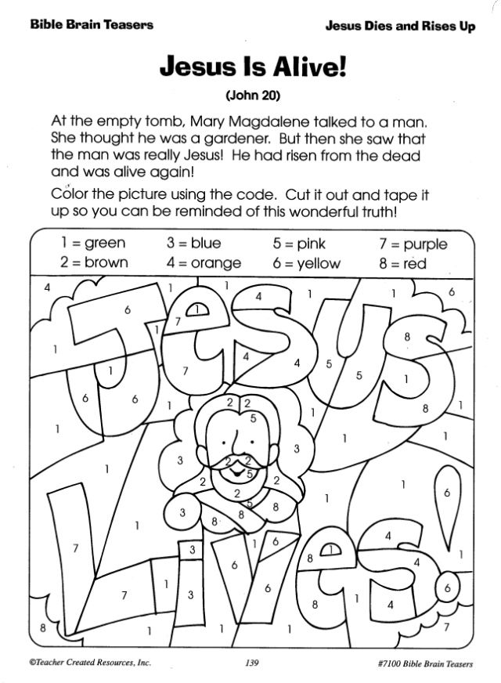
Children’s Page – For the Young at Heart:

