Schedule for the 2026 Lenten Special Services:

This year we will once again have mid week services. Please see the schedule below:

Wednesday February 25, 2026 6:00 pm Online Midweek Lenten Service
Wednesday March 4, 2026 6:00 pm Online Midweek Lenten Service
Wednesday March 11, 2026 6:00 pm Online Midweek Lenten Service
Wednesday March 18, 2026 6:00 pm Online Midweek Lenten Service
Wednesday March 25, 2026 6:00 pm Online Midweek Lenten Service
Palm Sunday March 29, 2026 10:00 am Procession with Palms
Maundy Thursday April 2, 2026 7:00 pm Maundy Thursday Worship Service
Good Friday April 3, 2026 10:00 am Good Friday Worship Service
Easter Sunday April 5, 2026 9:00 am Easter Resurrection Service
10:30 am Easter Potluck Breakfast

2026 Lenten Bible Study:

This year, our Lenten Bible Study will take place Tuesday mornings during the season of Lent beginning on February 24th at 10:00 am. This bible study will relate to the themes highlighted in our Mid-Week Lenten services. Each week will focus on the Gospel reading appointed for the previous Sunday. Each study is self contained so if you are not able to attend each week, you will be fine. Below you will find the dates and themes for each week. We hope you will be able to attend.

February 24th The temptation of Jesus according to Matthew
March 3rd Jesus’ interaction with the seeker, Nicodemus
March 17th Jesus’ interaction with the Samaritan woman at the well
March 24th Jesus’ interaction and healing of the blind man
March 31st Jesus’ interactions with Martha and Mary after the death of Lazarus

Prayer for the Beginning of Holy Week:
God of our salvation, we embark this day on a journey that we have made before, a journey that will once again sweep us into unexpected places, always in pursuit of the path of your obedient Son. Send your Holy Spirit to open our lips that our mouths may declare your praise and we may be guided on this path of penitence, prayer, and preparation. Amen.
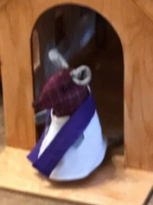

As we journey through these forty days, teach us to delight in Your presence, to hunger for Your truth, and to rest in the beauty of Your holiness.

TLC Book Club:

Once again, we invite you to join our Trinity Lutheran Church Book Club. Our next meeting will take place on March 4, 2026 at 2:00 pm at Elaine Janke’s home. The book we will be reading is ‘Small Things Like These’ by Claire Keegan. If you have any questions, please call Pastor Debra at the church (204) 735-2503 or on her cell phone at 1 (204) 807-1709.

2026 Lenten Food Drive:

This year we will be collecting food items for a Lenten Food Drive beginning on the first Sunday of Lent, February 25, 2026 and concluding on Palm Sunday March 29, 2026. Please look for the display in the Narthex at the church. Your donations are greatly appreciated especially during this time when many families find it hard to make ends meet. Any food items we receive will be delivered to the Cartier Cares Food Bank at 14 Main Street in Elie MB just prior to Easter Sunday.

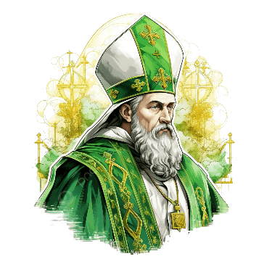
The Feast of St. Patrick- March 17, 461:

The first historical record of revelry for St. Patrick dates back to the 7th century in Ireland. With this said, during medieval times, texts show that people not only believed St. Patrick was a saint, but also that he was a part of God's final judgement of Irish people when they died. Over the years, Patrick became strongly identified with Ireland and would become one of its three patron saints, along with St. Brigid and St. Columba.
It may come as a surprise to some, that St. Patrick was not actually Irish. He was actually a Welshman. Much of what historians know about St. Patrick comes from two of his own writings. The two pieces were likely written in the 5th century, but Patrick did not date them or give much historical context. According to these writings, Patrick was captured when he was 16 years old by slave traders from Roman Britain. They took him to Ireland, where he is believed to have worked as shepherd. This hardship helped him rediscover his faith, and after 6 years of capture, he was able to escape back to Britain. He attributed his release to the works of God. After escaping, he spent many years training to become a bishop.
After becoming a bishop, Patrick had a vision in which he heard the voice of an Irish fisherman calling him back to the country he was formerly enslaved in. He then went back to Ireland where he shared the ‘Good News’ of Christs Gospel to the people. According to church records, Patrick died on March 17, 461.


An Irish Wish for St. Patrick’s Day:

May you always have
A sunbeam to warm you,
Good luck to charm you,
And a sheltering angel
So nothing can harm you,
Laughter to cheer you,
Faithful friends near you,
And whenever you pray,
Heaven to hear you.

May your joys
Be deep and many,
May your heart
be light and glad,
May you have the best
St. Patrick's Day
That you have ever had.

Poet: Julie Garwood
