40th Anniversary of the ELCIC 1986-2026:

This year marks the 40th anniversary of the Evangelical Lutheran Church in Canada! This milestone not only invites us to remember our story, but also to reflect on who we are today and how God is calling us forward as a church Living out God's grace and unconditional love. One of the key moments as we celebrate this milestone will be the ELCIC Day of Action on May 31, 2026. Our congregation here at Trinity will celebrate this day by having our annual family service and church picnic, and will be inviting members of our communities to come and celebrate along with us.

40th Anniversary of the ELCIC
1986 - 2026


Sunday School Church BBQ & Picnic:

The last day for our regular Sunday school will be on Sunday May 31, 2026. It will be a special family-oriented service. Following the service, please prepare to join us for a barbeque picnic on our front lawn with games for the children and those young at heart. We have had a great Sunday school year. Special thanks to our Sunday school leaders Liza Rasmussen, Susan Burns, Angela Fossay and Brenda Halstead and to the parents for their dedication in bringing their children to worship and Sunday school.

Pentecost and Holy Trinity:
Pentecost Sunday marks the end of the Easter season and celebrates the outpouring of the Holy Spirit on the early followers of Jesus. On Pentecost Sunday, Christians around the world celebrate this holy day, with symbols of flames, a dove and wind. Pentecost is a significant turning point in our Christian history. We recognize this special day as the birthday of the church.

The Sunday after Pentecost Sunday is always ‘Holy Trinity Sunday’. honor The Holy Trinity gives honour to God the Father, God the Son and God the Holy Spirit. While the word ‘Trinity’ does not appear in in Scripture, it is taught in Matthew 28:18-20 and 2 Corinthians 13:14 along with many other Bible passages. The Bible tells us, ‘And Jesus came and said to them, ‘All authority in heaven and on earth has been given to me. Go therefore and make disciples of all nations, baptizing them in the name of the Father and of the Son and of the Holy Spirit’ (Matthew 28:18-20).

Understanding the Holy Trinity is challenging mystery. It therefore can only come through the work of the Holy Spirit. It is appropriate then, that this mystery is celebrated on the first Sunday after Pentecost, when the outpouring of the Holy Spirit first occurred.

Youth:

The youth group gathered in April for a time of fellowship and fun. We painted bird houses and the youth really showed their creative side! Please keep an eye on your emails for details on future youth events. - Brianna & Carrie

A Mother’s Day Prayer:

Dear Lord, on this day dedicated to honoring mothers, we thank You for the blessings of motherhood. We are grateful for mothers’ love, strength, and guidance in shaping our lives. Bless them with joy, peace, and love on this special day and always. Amen
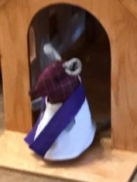
Leave footprints of love and kindness wherever you go!

Martin, the Missionary Church Mouse



Meridian Interchurch Baseball Game and BBQ:

Our annual slow-pitch baseball game and BBQ supper will take place this year on


Wednesday June 5, 2026
6:00pm Supper
7:00pm Baseball
@ Brunkild church and diamonds
PR332 at PR305
Please bring a lawn chair and a salad or dessert to share with all other food provided.

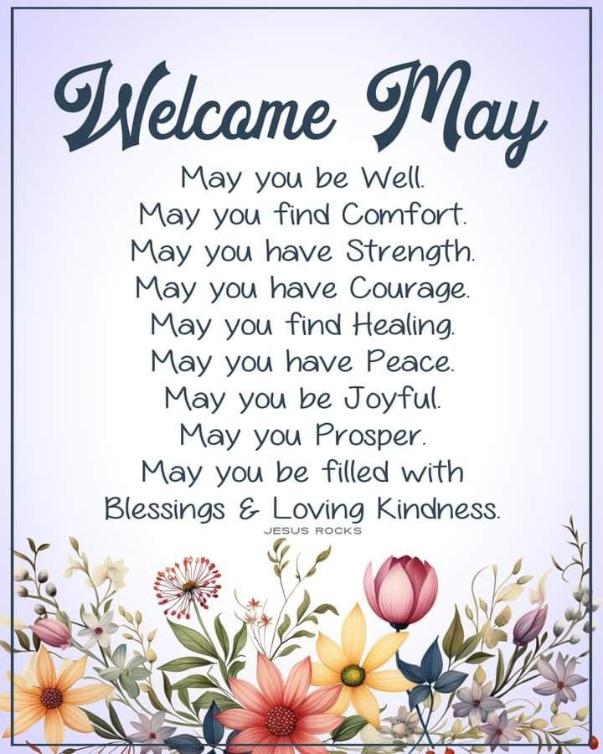
Springtime Prayer:

