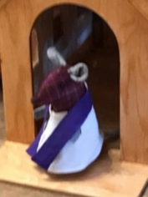
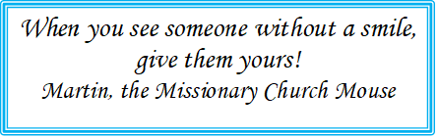

Meridian Interchurch Baseball Game and BBQ:

Our annual slow-pitch baseball game and BBQ supper will take place this year on:


Friday, June 5, 2026
6:00 pm Supper
7:00 pm Baseball
@ Brunkild church and diamonds
PR332 at PR305

Please bring a lawn chair and a salad or dessert to share all other food provided.

Youth:

The youth group gathered in May for a time of fellowship and fun. We had a big party for “Everybody’s birthday!” The youth played games, enjoyed some snacks, cake and presents. We will now be breaking for the summer months, but we cannot wait to see everyone again in the fall. Have a great summer! - Brianna & Carrie

Trinity Church Council Retreat:

Our Trinity Church Council met on May 9th at Camp Assiniboia for our annual retreat. The keynote speaker was Deacon Michelle Collins, assistant to Bishop Jason. She has been working with us to assist us with ministry goals and evaluate how we have been meeting these goals and also looking at the areas that we still need to address. This past year we were able to meet several of our goals including the congregational decision to donate a portion of the Geordie Kilt estate in support of campus ministry. Another important ministry goal that was met was community outreach. The third goal that was set was in the area of stewardship and recruitment and support of our volunteers. This final goal from last year is still a work in progress. One new goal is the ongoing support of adults in our congregation for children and youth ministry.
