A message from the Editor:

Hello everyone! If ever you have anything you would like included in upcoming newsletters, please email me at: briannahoude@gmail.com
-Brianna

Pentecost 2026:

Why Does the Date of Pentecost Change Every Year?
This year Pentecost Sunday took place on May 24, 2026. Did you know that the date for Pentecost Sunday changes every year? This change is directly related to when we celebrate Easter Sunday. The date for Easter Sunday also changes every year.

Since Easter Sunday itself does not have a fixed date and the date for Pentecost Sunday always occurs 50 days after Easter, the Day of Pentecost also does not have a fixed date.

So why is this? Easter Sunday is calculated as the first Sunday after the first full moon following the spring equinox. Once the date of Easter is known, Pentecost is simply counted forward by fifty days. This places Pentecost on a Sunday, seven weeks after Easter. The name Pentecost comes from a Greek word meaning fiftieth, reflecting this exact timing.

In the Bible, Pentecost was originally a Jewish feast known as the Feast of Weeks. It was celebrated fifty days after Passover and was associated with the harvest. This explains why many people from different regions were present in Jerusalem in Acts 2.

For Christians, Pentecost took on a deeper meaning when it was recognized as the day the Holy Spirit came upon the followers of Jesus. This event marked the birthday of the church and the beginning of the spread of the Christian message. It was not planned by human effort. It began with divine action.

Understanding the date helps place the event in context. Pentecost is not an isolated moment. It follows the resurrection of Jesus and continues the sequence of events that began at Easter. That is why the date changes, but the meaning does not.

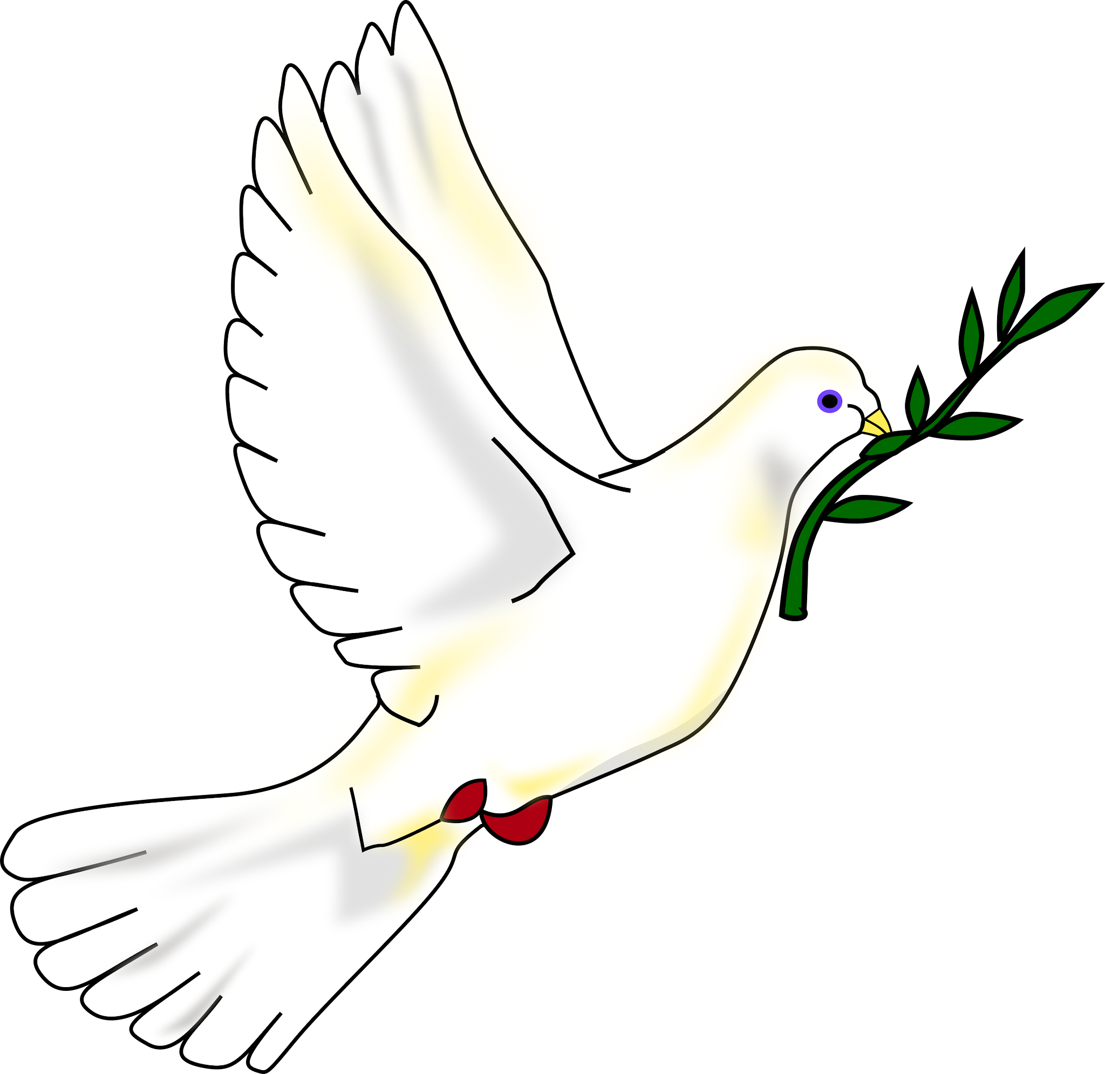
Each year, Pentecost reminds believers of the same event recorded in Acts 2. It marks the moment when fear turned into boldness and when a small group became a growing movement. The significance of Pentecost remains the same every year. Happy Birthday Church!

Pastor Debra at the Clergy Conference:

Pastor Debra will be away from Tuesday, June 9th to Friday June 12th at the annual Anglican – Lutheran clergy conference in Gimli, MB. If you need to speak to her, please contact her on her cell phone at 204-807-1709.
The theme of this year’s conference is “Exploring the Possibilities, Sustainability and Faithful Stewardship of our Church Buildings”. The keynote speaker will be Katja Brittain. She offers workshops and has a monthly blog across the ELCIC sharing insights and practical tools to help congregations align their buildings with their mission.

Happy Father’s Day 2026:

Father's Day is June 15, 2026! It is a celebration of appreciation for all fathers, grandfathers, step-fathers, and all the men who provide leadership, guidance, and protection in your life. In addition to the gifts of appreciation and dinner outings, let's focus on sharing words of gratitude and blessings as we pray for our fathers - both the biological and spiritual.

Dear Lord, we thank You for the gift of fatherhood. Bless all fathers with strength, wisdom, and love. May they reflect Your grace and guidance in their journey of raising and nurturing their children. Surround them with Your peace, and let Your joy fill their hearts each day, in Jesus name we pray. Amen.

What is a dad?

A Dad is a person who is loving and kind,
And often he knows what you have on your mind.
He's someone who listens, suggests, and defends ~
A dad can be one of your very best friends!
He's proud of your triumphs, but when things go wrong,
A dad can be patient and helpful and strong.
In all that you do, a dad's love plays a part ~
There's always a place for him deep in your heart.
And each year that passes, you're even more glad,
More grateful and proud just to call him your dad!
Thank you, Dad ….
for listening and caring, for giving and sharing,
but, especially, for just being you!

Happy Father's Day
Author Unknown

