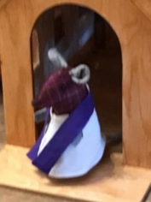
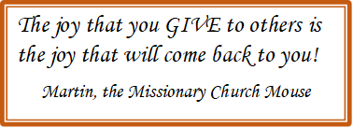

___________________________________________Starbuck History Book Committee:

The Starbuck History Book Committee would like to extend a very big thank you to Trinity Lutheran Church for allowing us to hold our regular meetings in the church!! We are happy to provide the following update on our progress:

Thank you to everyone who has submitted a family history!! We have received close to 250 family histories to date. The final cut-off for receipt of family submissions is JUNE 30, 2026. If you still intend to submit, please contact us by email immediately! We can provide assistance if necessary.

The committee and many community members continue to work on researching and writing content for the book, and we have made significant progress on the initial drafts. Our publication target is Summer 2027. Further information regarding book purchases will be provided in early 2027.

We continue to look for the stories that mean the most to our community. Neighbours helping neighbours, volunteering, memorable characters, great summers, harsh winters, good crops and bad crops, floods, school days, church events, clubs, sports — we are interested in anything that demonstrates what life in Starbuck was to you and to previous generations. Every contribution helps us build a fuller, more meaningful picture of our shared history.

Stories, anecdotes, and photographs can be sent by email to:

starbuckhistory@gmail.com

If you prefer to mail a letter, please note that our address is now:

Starbuck History Book, c/o Tammy Shirtliff,
P.O. Box 318, Starbuck MB, R0G 2P0.

You can also message us on the Starbuck History Book Facebook page. If you'd like to speak with someone directly, please send your phone number by email and a committee member will return your call.

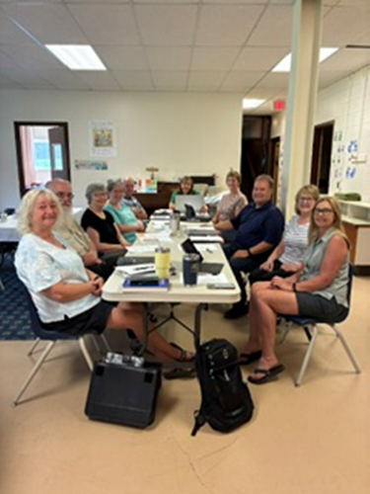
Thank you for your continued support, and for helping preserve the memories and events that make Starbuck unique!


___________________________________________Congratulations to our 2026 Graduates:

This year we recognize two of our members who will be graduating. We remember Sawyer Nabess who will be graduating from Grade 8 and Tyler Kendall who will be graduating from Grade 12. We are proud of you for all that you have achieved and are confident that you have successful futures ahead of you.

One part of your life’s journey is complete and now you prepare to begin another phase that will take you to new and unimagined places. As you prepare for your next journey, we hope that you remember those who have loved and supported you and will continue to love and support you in all you do.

We give you blessings of good will and love as you journey forth to a new school and into the world. We thank you for the laughter and fellowship that you have shared with us and pray that as you begin your next journey, you will remember that you are not alone. We are here for you.

___________________________________________Congratulations to the following couples:

Please remember the following couples in your prayers this summer as they are married.

Laura Ammeter and Taylor Post July 11, 2026

Connor Shirtliff and Hayley Jenkins July 18, 2026

Pauline Ammeter and Eric Hysop August 8, 2026

Brianna Houde and Tyler Ammeter August 15, 2026

May God’s love be the foundation of your marriage, God’s wisdom guide your steps, and God’s blessings fill your home with joy and peace all the days of your life.
