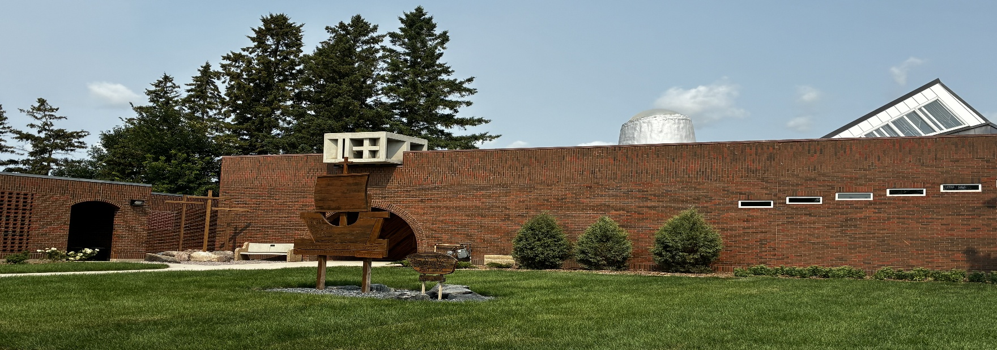

Trinity Lutheran Church Newsletter
September 2026

A Message from Pastor Debra:
(1 Corinthians 13:1-7)
If I speak in the tongues of mortals and of angels, but do not have love, I am a noisy gong or a clanging cymbal. And if I have prophetic powers, and understand all mysteries and all knowledge, and if I have all faith, so as to remove mountains, but do not have love, I am nothing. If I give away all my possessions, and if I hand over my body so that I may boast, but do not have love, I gain nothing.
Love is patient; love is kind; love is not envious or boastful or arrogant or rude. It does not insist on its own way; it is not irritable or resentful; it does not rejoice in wrongdoing, but rejoices in the truth. It bears all things, believes all things, hopes all things, endures all things. Love never ends.”
If anyone was to ask me to reflect upon my summer, I suppose I would say, it was the summer of love. This summer I had the privilege of presiding over three weddings, a reaffirmation of wedding vows service, an internment and a funeral. Although this may seem unusual, I also include the interment service of Pastor Gordon Hendrickson and the funeral service of Alex Ross. A common theme running through each of these five services was the theme of love.
While only one of the three married couples chose to use the familiar First Corinthians 13 passage, I found myself doing a great deal of reflecting upon it and specifically its biblical context. In this reading, St. Paul is describing for the people of Corinth the kind of love that God has for each of us and wants us to have for one another. He was talking to the people of Corinth about God’s love, not because they understood it and were practicing it. In truth, they were a bit confused about God and about God’s love for us. Some thought that God’s love was conditional and the only ones entitled to it were the ones who had power, were wealthy, healthy and appeared to have importance. Others believed that God’s love was exclusive. So, Paul in this passage was explaining what God’s love is and what God’s love is not.
“Love is patient; love is kind; It bears all things, believes all things, hopes all things, endures all things. Love never ends.” This is what God’s love is. God’s love is not, “Envious or boastful or arrogant or rude. It does not insist on its own way; it is not irritable or resentful; it does not rejoice in wrongdoing, but rejoices in the truth.”
I believe that most of us are drawn to the words of love defined in this passage because we hope that all of our relationships will be expressions of them. They remind us that being in a relationship requires intentional work. It is work that requires us, to the best of our ability, to speak with patience, consideration and empathy. This work invites us to put ourselves in the shoes of the one we are dealing with, without resentment or judgement. Working on our relationships is often not easy work and it is very good work. While none of us are perfect at this, it is something that we endeavor to strive toward in order to have harmony with one another.
This became the summer of love for me because in each of the six services I presided over, loving relationships was the theme. The words of love that were reflected in the Corinthians passage were evident in the ways each couple cared for one another and in the vows they shared. Each couple, including the couple who reaffirmed their vows, wrote their own vows. The vows were a wonderful reflection of the relationship they had and still hoped to grow into. This was also the case for the interment service for Pastor Gordon and the funeral service of Alex Ross. Both of these services were witnesses of the love that these two men had for their wives, children, grandchildren and extended family as well as colleagues and friends. Their entire lives were testimonials to love.
Jesus said that we show our love for God when we love and serve those around us. In a world where we often hear of the lack of respect, intolerance and indifference that human beings have toward other human beings, it was great to be continually reminded that there are good people, engaging in thoughtful, loving relationships. I think there are more people like this in our communities than the media ever acknowledges.
“No one has ever seen God; if we love one another, God lives in us and God’s love is perfected in us.” (1John 4:12)



Sunday Usher Duties:

BEFORE THE SERVICE
- Put up the hymn numbers
- Turn off the fan in the sanctuary
- Light the candles on the altar
- Turn on the Lectern Light
- Fold the bulletins
- Hand out the bulletins
- Ring the Bells (Begin ringing the bells 5 minutes before the service. Let them ring between 15 and 20 times)
- Take the offering plate to the altar at the time of the offering
- Count the number of people in church.

AFTER THE SERVICE
- Check the number who have joined us online and write it on the calendar provided on the bulletin board.
- Extinguish the candles on the altar
- Put left over bulletins in the recycling bin in the cloak room
- Check the pews for any garbage


Offering Envelopes:

We kindly ask that you please complete the date, name and address portions of each offering envelope used. This is a CRA requirement for all charitable donations. This also helps to make the Sunday morning count run smoothly.

Please also note that all cheques must be made payable to Trinity Lutheran Church. It is not necessary and adds confusion when the word 'Starbuck' is added to this line.
We are deeply grateful for your continued and generous support of the work and ministry of Trinity Lutheran Church.

Treasurer Report:

Income continues to meet budget (+2%). The underrun in expenses (-12%) is primarily due to some of costs for Landscaping and Technology (Projector project) not yet being expensed, although it looks promising that overall expenses will remain below budget estimates.
 | Jan-July 2026 | YTD Budget
Total Income | $84,595 | $82,575
Total Expense | $133,651 | $151,133
Net Income | -$49,057 | -$68,557

September Cleaning Schedule:

August 31-September 6 Kevin & Sue V.
September 7-13 Shawn & Carla L.
September 14-20 Jim & Vicki P.

September 21-27 David & Joan K.

Readings for September 2026:

September 6, 2026 15th Sunday after Pentecost
First Reading Ezekiel 33:7-11
Psalm Psalm 119:33-40
Second Reading Romans 13:8-14
Gospel Reading Matthew 18:15-20

September 13, 2026 16th Sunday after Pentecost
First Reading Genesis 50:15-21
Psalm Psalm 103:[1-7] 8-13
Second Reading Romans 14:1-12
Gospel Reading Matthew 18:21-35

September 20, 2026 17th Sunday after Pentecost
First Reading Jonah 3:10 - 4:11
Psalm Psalm 145:1-8
Second Reading Philippians 1:21-30
Gospel Reading Matthew 20:1-16

September 27, 2026 18th Sunday after Pentecost
First Reading Ezekiel 18:1-4, 25-32
Psalm Psalm 25:1-9
Second Reading Philippians 2:1-13
Gospel Reading Matthew 21:23-32

Happy September! The world shall now transform into pumpkin everything!
Martin the Missionary Mouse

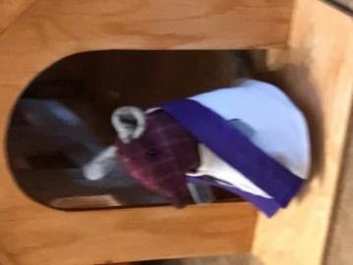

New Look for Newsletter:

We are excited to introduce you to the new look for our Trinity Lutheran Newsletter! You will notice the format has changed and we hope that you are able to follow along with no problems. We want to take a moment to thank Brianna (Houde) Ammeter for her many, many years of being the Editor for our newsletter. She has been a huge asset to providing us all with some great information about our church. At this time, we wish to inform the congregation that the editing of our Trinity newsletter will now be done by our office administrator Donna. Brianna will continue along with Carrie Livingston to be a key member of our Youth Group Leadership Team. THANK YOU FOR ALL YOU HAVE DONE Brianna!!!!



Thanksgiving Food Drive:

Once again, we will be collecting dry goods for our Thanksgiving Food Drive beginning August 30, 2026 until Thanksgiving. Please look for the display in the Narthex of the church. Anything you can give will be greatly appreciated. Your donations will be given to the Elie Food Bank.
“O Give Thanks unto the Lord for he is good and God’s mercy endures forever.”


A Back-To-School Prayer:


Dear Heavenly Father, as we embark on a new school year, we come to You seeking Your guidance and blessings. Please watch over all the students, teachers, staff, and parents filling their hearts with Your peace and wisdom. Help each one to face the challenges ahead with courage and faith, trusting in Your presence and provision. May this year be filled with growth, learning, and the joy of discovering more about Your world. Keep everyone safe and let Your love shine through in all that we do. In Jesus’ name, Amen.

Sunday School Rally Day 2026:



This year we will celebrate our 2026-2027 Sunday school year with a special ‘Sunday School Rally Day’. This family-oriented service will take place on Sunday, September 20, 2026 at 10:00 am. Included in the service will be our ‘Blessing of the Backpacks’ and the Installation of our Sunday school teachers. For anyone in the congregation wishing to have their backpacks and school equipment blessed, you are invited to place them before the altar for a special blessing. As well, we will be presenting the bibles to our grade 3 students, Nolan Nabess and Naomi Hitching. We look forward to seeing you!



Sunday School Helpers Needed:

We Need Your Help. Would you consider assisting in our Sunday school? This year we have not been able to recruit enough support staff to assist with the children God has blessed us with. Special thanks to Liza Rasmussen, Brenda Halstead and Angela Fossay for their dedication to this ministry. If any others would like to come forward to help teach, we would greatly appreciate it. We currently could use three more helpers.

TLC Book Club:


We will resume our book club meetings on Tuesday, September 15, 2026 at 1:30 pm at Elaine Janke’s home. For the next book club, we will be reading two summertime books: My Every Breath: A Memoir of Love, Loss & Hope by Anna Maynard and Lady Tan’s Circle of Women by Lisa See. If you are interested in attending, please call Pastor Debra at the church (204) 735-2503 or on her cell phone at (204) 807-1709.

Lutheran Area Conference Meeting:

Members of our ELCIC area congregations will be getting together on Saturday, October 24, 2026 from 10:00 am to 2:00 pm at the Morris United-Lutheran Church of the Cross in Morris, MB. The purpose of this meeting will be to re-connect, share our gifts of ministry and pray for one another. The last time we gathered as a conference was May 25, 2019. We recognize that this meeting is long overdue and so encourage members of the congregation to come and join in the conversation and visioning for the future.

