Bible Study:

Once again this fall, we will be offering an Adult Bible Study on St. Paul’s letter to the Romans. The study will take place on Tuesday mornings from 10:00 am to 11:00 am beginning on Tuesday October 20, 2026 and concluding on Tuesday November 24, 2026.

The title of the Bible Study is ‘Good News that Changes Everything’. It is based on a study by Melissa Spoelstra. In her introduction to this study, she says: “Bad news surrounds us. It comes through our computers and television screens with reports of natural disasters, violence and tragedy. We encounter it in doctor’s offices, strained relationships and home or car repairs. And when those we love receive bad news, it compounds our personal pile of woes.

All of this bad news can overwhelm us and cause us to plead with Jesus to return. In the midst of our complicated lives, we can drift toward cynicism, fear, or despair. As followers of Jesus, we need constant reminders that through all of our trials, we carry treasured good news for a broken planet.

The letter that St. Paul wrote to the people of Rome has been a source of spiritual transformation and renewal throughout history, impacting the lives of important leaders such as St. Augustine, John Chrysostom, Martin Luther, John Calvin, John Wesley, Karl Barth and many others. In fact, Luther acknowledged its power for all of us when he said, ‘We can never read it or ponder over it too much, for the more we deal with it, the more precious it becomes and the better it tastes.’ As we read and study this timeless letter, we cannot help but be affected by it.”

The following are the titles for each of our weeks of study.
- Good news about Faith (Romans 1-3)
- Good news about Hope (Romans 4-5)
- Good news about Daily Life (Romans 6-8)
- Good news about God’s Plan (Romans 9-11)
- Good news about Relationships (Romans 12-14)
- Good News About Eternity (Romans 15-16)



2026 COOL Field Worship Service:

Thanks to all who participated and supported the COOL Field worship service. There was roughly 115 people who attended. Special thanks to our Trinity Lutheran congregation members who attended. We had a great representation from our congregation.

Special thanks to Eric and Sandra Dyck and family and Susan for hosting. Thanks to Pastor Randy, Pastor Debra and Kathy for leading the worship service. Also special thanks to worship group Eric, Leona and Jacob for leading music with great song selection. There was a great turnout from all our supporting churches Springstein Mennonite, St. Paul’s Roman Catholic in Starbuck, Trinity Lutheran Church, Starbuck United Church, Prairie Spirit United Church in Winnipeg, St. Charles’s United church in Headingley, as well as Charleswood Mennonite. There was $1,500 in donations collected that will go towards COOL Foodgrain’s.

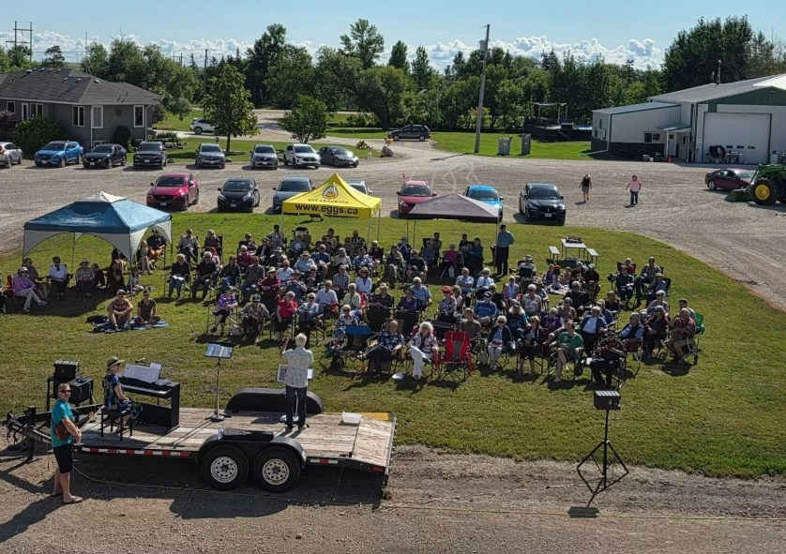

Contact Us
Phone: 204-735-2503
Website: tlcstarbuck.com
Address: Box 118, 43 River Avenue
Starbuck, MB
R0G 2P0

