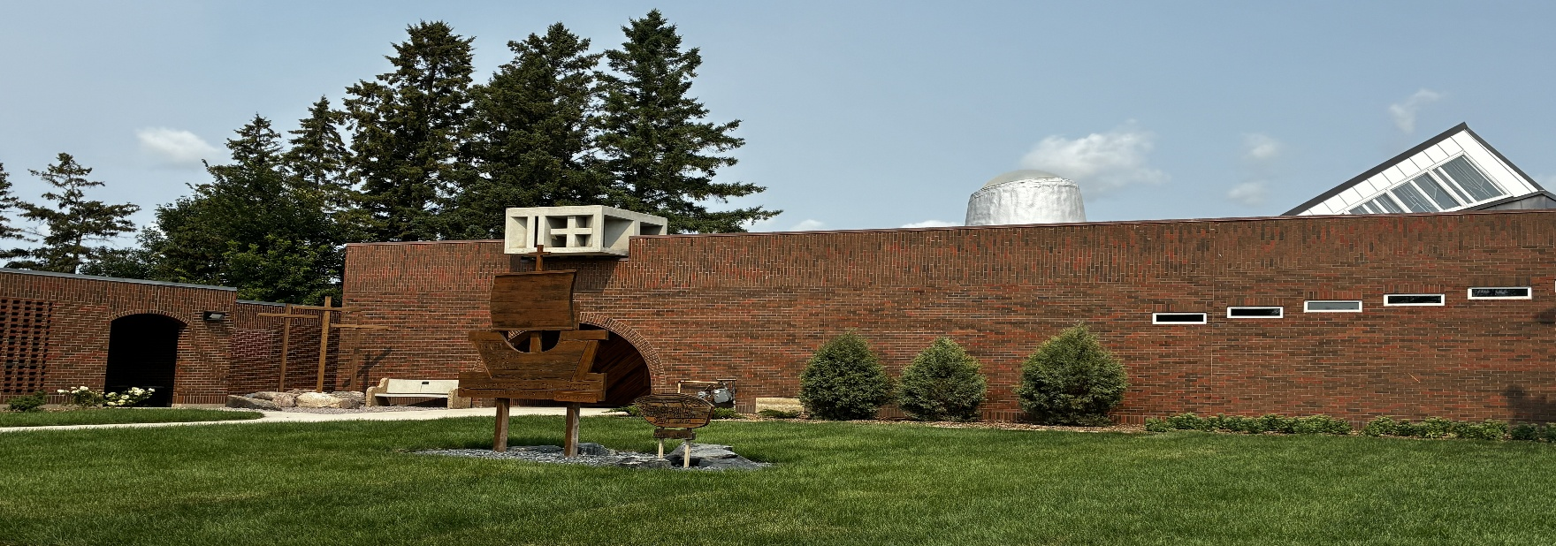

Trinity Lutheran Church Newsletter
October 2026

A Message from Pastor Debra:
As I begin this article, we are fully in the throes of a Manitoba autumn. The colours this year to me are striking. The gold, the browns and reds are vibrant. As I look around, I cannot help but wonder how we got to the month of October again. But here we are. It seems like we were just getting ready for spring. I know that others share in this sentiment and time passes.
It was my intention this September to hit the pavement running. I had been so excited about beginning our first communion class with the young children of our church. I was eager to start a new Sunday school year in a new way. I had a wonderful summer engaging with the young couples of our congregation and their friends, and so I thought I was ready to go with energy, eagerness and enthusiasm.
Instead of hitting the pavement running, I just hit the pavement. I guess that is how it goes sometimes. We think we have our trajectory planned and we are stopped in our tracks. When this happens, we fumble around until we realize that where we are currently at, is in fact, the place we are at. We can fight it or embrace it, and accept that there will be opportunities in it. I hope that this is where I am at; the place of embracing my current situation. I say this knowing full well, that there may still be periods of fumbling around.
In truth, there are benefits to every situation we find ourselves in. We just need to look for them. Or better still, we need to listen to the people around us who love and care for us, who are saying what we eventually actually hear.
Once again, I am learning that when we are forced to ‘stop’, opportunities arise. For example, opportunities for rest and reflection. Opportunities to simply look out a picture window to see the rabbits, squirrels and birds playing hide and seek among the grass and trees. I am learning to listen for the bird song and chirping, and how it is more alive in the early morning and late afternoon then at any other time of the day. These are gifts from God. I have become aware again of how even in difficult circumstances our Lord provides.
As we approach this Thanksgiving weekend, what are some of the gifts you are able to embrace in the situation, good, bad or indifferent, that you find yourself in? How might God be providing for you in this new season?
Will the words, ‘O give thanks unto the Lord for he is good and his mercy endures forever’ be more than just words on a page for you this Thanksgiving? It has been a bit of a struggle for me to get to this place this year. Sometimes, that is the case. Sometimes, I have not been where I want to be. As we begin this month of October, I truly am Thankful to God for all God’s blessings. I am especially Thankful for each of you! Happy Thanksgiving.

Sunday Usher Duties:

BEFORE THE SERVICE
- Put up the hymn numbers
- Turn off the fan in the sanctuary
- Light the candles on the altar
- Turn on the Lectern Light
- Fold the bulletins
- Hand out the bulletins
- Ring the Bells (Begin ringing the bells 5 minutes before the service. Let them ring between 15 and 20 times)
- Take the offering plate to the altar at the time of the offering
- Count the number of people in church.

AFTER THE SERVICE
- Check the number who have joined us online and write it on the calendar provided on the bulletin board.
- Extinguish the candles on the altar
- Put left over bulletins in the recycling bin in the cloak room
- Check the pews for any garbage


Offering Envelopes:

We kindly ask that you please complete the date, name and address portions of each offering envelope used. This is a CRA requirement for all charitable donations. This also helps to make the Sunday morning count run smoothly.

Please also note that all cheques must be made payable to Trinity Lutheran Church. It is not necessary and adds confusion when the word 'Starbuck' is added to this line.
We are deeply grateful for your continued and generous support of the work and ministry of Trinity Lutheran Church.

Treasurer Report:

Income remains strong, actually ahead of budget (+6%). The underrun in Expenses (-14%) is primarily due to some of costs for Landscaping and Technology (Projector project) not yet being expensed, although it looks promising that overall expenses will remain well below budget estimates.

 | Jan-Aug 2026 | YTD Budget
Total Income | $99,798 | $94,265
Total Expense | $145,450 | $169,145
Net Income | -$45,652 | -$74,880
October Cleaning Schedule:

September 28-October 4 Terri Mollot
October 5 – 11 Michelle Ammeter
October 12 – 18 Janis M. & Mel S.

October 19 – 25 Leah Burns

Readings for October 2026:

October 4, 2025 19th Sunday after Pentecost
First Reading Isaiah 5:1-7
Psalm Psalm 80:7-15
Second Reading Philippians 3:4b-14
Gospel Reading Matthew 21:33-46

October 11, 2026 20th Sunday after Pentecost
First Reading Isaiah 25:1-9
Psalm Psalm 23
Second Reading Philippians 4:1-9
Gospel Reading Matthew 22:1-14

October 18, 2025 21st Sunday after Pentecost

First Reading Isaiah 45:1-7
Psalm Psalm 96:1-9 [10-13]
Second Reading 1 Thessalonians 1:1-10
Gospel Reading Matthew 22:15-22

October 25, 2025 Reformation Sunday

First Reading Jeremiah 31:31-34
Psalm Psalm 46
Second Reading Romans 3:19-28
Gospel Reading John 8:31-36

Today I choose to live with GRATITUDE, for the LOVE that fills my heart, the PEACE that rests within my spirit and the voice of HOPE that says all things are possible.
Martin, the Missionary Mouse

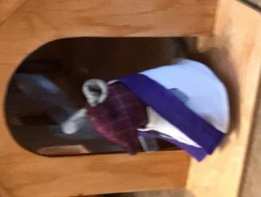

Thanksgiving Food Drive:


Once again, we will be collecting dry goods for our Thanksgiving Food Drive beginning August 30, 2026 until Thanksgiving. Please look for the display in the Narthex of the church. Anything you can give will be greatly appreciated. Your donations will be given to the Elie Food Bank.
“O Give Thanks unto the Lord for he is good and God’s mercy endures forever.”

Confirmation Class 2026-2027:


This year our confirmation class will generally be meeting on Thursday afternoons from 12:00 – 12:45 pm. The following individuals will be participating in this year’s class: Mackenzey Thornson and Quinn Rasmussen. Please remember Mackenzey and Quinn and their families in your prayers as they continue in their faith journey.

Sunday School Helpers Needed:


We Need Your Help. Would you consider assisting in our Sunday school? This year we have not been able to recruit enough support staff to assist with the children God has blessed us with. Special thanks to Liza Rasmussen, Brenda Halstead and Angela Fossay for their dedication to this ministry. If any others would like to come forward to help teach, we would greatly appreciate it. We currently could use three more helpers.



TLC Book Club:

The next TLC book club meeting will be on Tuesday, October 27th at 1:30 pm at Cathy Kendall’s home. The book we will be reading is Kisses from Katie by Katie Davis. If you are interested in attending, please call Pastor Debra at the church (204) 735-2503, or on her cell phone at (204) 807-1709.



Worship at St. Paul’s Lutheran

Once again this year, we are reaching out to the people of St. Paul’s Lutheran Church in Brunkild as a way of promoting support and fellowship to our local Lutheran brothers and sisters. We look forward to another joint worship service together. This service will take place on Sunday October 18, 2026 at 10:00 am in Brunkild. There will be no service that week here at Trinity. Please plan to come to St. Paul’s in Brunkild for worship and stay for a time of refreshment and fellowship.

