Youth Kick-Off Event:

Happy back-to-school and back-to-youth season everyone! Carrie has taken a step back from youth this year. We are so grateful for everything she has done for our youth over the years; she will be greatly missed! That being said, Shayna Azarov will be stepping in to fill her place! Please join us in welcoming Shayna to our youth family! We are so excited to have her on board.

Our first youth event of the year will take place Sunday, October 4th from 4:00-6:00pm in the church basement. We will be decorating candy apples and playing some games! Please let us know if your youth are able to attend by October 1st at the latest so that we can plan accordingly. Please keep an eye on your emails for details regarding future events!
Brianna & Shayna

Choir and Handbell Practice:


Please consider joining our church choir and handbell choirs. On Wednesday evenings, the choir meets at 7:00 pm and the handbell choir meets at 8:05 pm. Everyone is welcome to join!

Lutheran Area Conference Meeting:

Members of our ELCIC area congregations will be getting together on Saturday, October 24, 2026 from 10:00 am to 2:00 pm at the Morris United-Lutheran Church of the Cross in Morris, MB. The purpose of this meeting will be to re-connect, share our gifts of ministry and pray for one another. The last time we gathered as a conference was May 25, 2019. We recognize that this meeting is long overdue and so encourage members of the congregation to come and join in the conversation and visioning for the future.

Bible Study:

Once again this fall, we will be offering an Adult Bible Study on St. Paul’s letter to the Romans. The study will take place on Tuesday mornings from 10:00 am to 11:00 am beginning on Tuesday October 20, 2026 and concluding on Tuesday November 24, 2026.

The title of the Bible Study is ‘Good News that Changes Everything’. It is based on a study by Melissa Spoelstra. In her introduction to this study, she says: “Bad news surrounds us. It comes through our computers and television screens with reports of natural disasters, violence and tragedy. We encounter it in doctor’s offices, strained relationships and home or car repairs. And when those we love receive bad news, it compounds our personal pile of woes.

All of this bad news can overwhelm us and cause us to plead with Jesus to return. In the midst of our complicated lives, we can drift toward cynicism, fear, or despair. As followers of Jesus, we need constant reminders that through all of our trials, we carry treasured good news for a broken planet.

The letter that St. Paul wrote to the people of Rome has been a source of spiritual transformation and renewal throughout history, impacting the lives of important leaders such as St. Augustine, John Chrysostom, Martin Luther, John Calvin, John Wesley, Karl Barth and many others. In fact, Luther acknowledged its power for all of us when he said, ‘We can never read it or ponder over it too much, for the more we deal with it, the more precious it becomes and the better it tastes.’ As we read and study this timeless letter, we cannot help but be affected by it.”

The following are the titles for each of our weeks of study.
- Good news about Faith (Romans 1-3)
- Good news about Hope (Romans 4-5)
- Good news about Daily Life (Romans 6-8)
- Good news about God’s Plan (Romans 9-11)
- Good news about Relationships (Romans 12-14)
- Good News About Eternity (Romans 15-16)



Living Well in the RM of Macdonald:

The 2026 Living Well symposium is being held in Oak Bluff! Last year was such a success they have decided to do it again! Tickets are $15.00 and includes a whole day of activities, speakers, booths, door prizes, draws and a delicious lunch! Get your tickets ahead by calling one of the following: Mike or Wendy (Oak Bluff) 204-770-7838, 204-770-2361; Jane (La Salle) 204-227-2975; Nancy (Sanford) 204-471-7056; Ronda (Brunkild) 204-794-4821 or Leanne 204-736-2255.

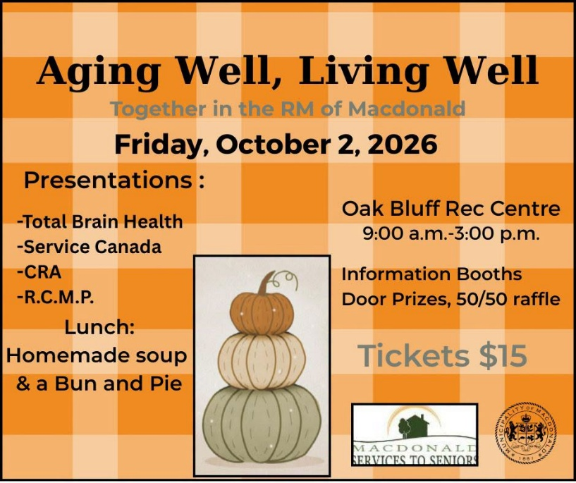



Luther Seal
What does this mean?
THE BLACK CROSS IN A HEART
remains its natural color. This is to remind me that it is faith in the Crucified One that saves us. Anyone who believes from the heart will be justified (Romans 10:10). It is a black cross, which mortifies and causes pain, but it leaves the heart its natural color. It doesn’t destroy nature, that is to say, it does not kill us but keeps us alive, for the just shall live by faith in the Crucified One (Romans 1:17).

A WHITE ROSE
shows that faith gives joy, comfort, and peace. In other words, it places the believer into a white, joyous rose. Faith does not give peace and joy like the world gives (John 14:27). This is why the rose must be white, not red. White is the color of the spirits and angels (cf. Matthew 28:3; John 20:12).

THE SKY-BLUE FIELD
symbolizing that a joyful spirit and faith is a beginning of heavenly, future joy, which begins now, but is grasped in hope, not yet fully revealed.

A GOLDEN RING
around the field of blue is a golden ring to symbolize that blessedness in heaven lasts forever and has no end. Heavenly blessedness is exquisite, beyond all joy and better than any possessions, just as gold is the most valuable and precious metal.
(From: Letter from Martin Luther to Lazarus Spengler, July 8, 1530.)

Wednesday Lunch at Starbuck Hall:

Every Wednesday at 11:30 am, members of the Starbuck community gather for lunch at the Starbuck Community Hall. The cost of the lunch is $10.00. It is often followed by a program but if you would prefer, you can just come for the lunch. If you would like to attend, please contact Leanne Wilson at 204-736-2255 or info@macdonaldseniors.ca prior to each Wednesday.



All Saints Sunday:

Each November 1st, we remember all those individuals who have been received back into the loving arms of our Creator God. November 1 is All Saints Day. We Lutherans usually recognize it on the Sunday after Reformation. The Bible teaches us that we are all small -‘s’- saints. God calls a "saint" anyone who trusts in Christ alone for salvation.
The Christian festival of All Saints Day comes from a conviction that there is a spiritual connection between those in Heaven and those on Earth. In our Lutheran tradition, this day honors all those who have passed on to the Kingdom of Heaven. It gives God earnest gratitude for the lives and deaths of all God’s people, remembering those who were well-known and those who were not known, alike.
On All Saints Sunday, November 1, 2026, we will remember all of our relatives and friends who have gone to be with Jesus in this past year. Here at Trinity, we remember the following individuals with the tolling of a bell.

Names of those who Died Date of Death
David Orville Rasmussen November 18, 2025
Shirley Agnes Rasmussen December 2, 2025
Gordon Palmer Hendrickson December 6, 2025
Gary James Rasmussen March 8, 2026
Alexander Harold Ross August 16, 2026

In addition to those who passed away, we also remember those who were born, baptized and who made public Affirmation of their faith (Confirmed), with the tolling of a bell.

Birth Date of Birth
Norah Elizabeth Surgenor September 15, 2026

Baptism Date of Baptism
Enzo Michael Fajardo December 14, 2025
Charley Rae M. Thornson April 12, 2026
Sophie Ella Jackson October 4, 2026

Confirmation Date of Confirmation
Sophie Ella Jackson October 4, 2026



Contact Us
Phone: 204-735-2503
Website: tlcstarbuck.com
Address: Box 118, 43 River Avenue
Starbuck, MB
R0G 2P0

