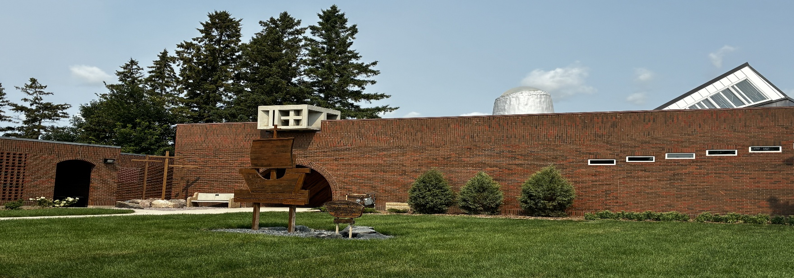

Trinity Lutheran Church Newsletter
November 2026

A Message from Pastor Debra:
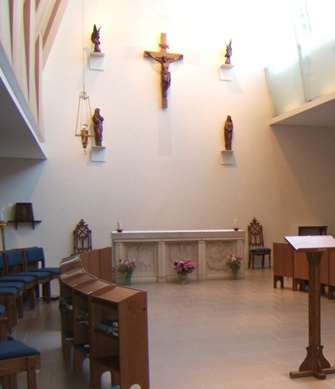

Above, you will see a picture of the chapel at the convent of the Sisters of St. John the Divine in Toronto, Ontario. This is the Convent where I spent five and a half years under special Call before coming here to Trinity. Above the altar in the chapel, there is a large crucifix. The two statues above to the right and left of the crucifix are angels. The statue to the left below is of Jesus’ beloved disciple John and to the right was his mother Mary.
At the end of this reflection, you will find the words of a hymn by John L. Bell, ‘We Cannot Measure How you Heal’. These are beautiful words.
As I was thinking about what I would write this month, my mind ventured to the SSJD chapel and to the words of this hymn. At the beginning of this month of November, we will remember All Saints Sunday and all of our loved ones who have gone before us and are at rest with God. Towards the end of this month on November 22nd, we will celebrate ‘Christ the King Sunday’. Christ the King Sunday is always the very last Sunday of the church year before we begin a new year with Advent One. Christ the King Sunday or Reign of Christ serves two purposes. The first is that Christ is our King and Sovereign Lord and the second is the reminder that each of the seasons of the church year follow the life of Christ.
On All Saints Sunday, as on Christ the King Sunday, we gather in thanksgiving, with deep reverence to our Creator God who has not abandoned us to this world and whose reconciling nature is continually transforming us into the image of Christ. We also stand with all of the faithful who have heard God’s call, responded to that call and through God’s grace and mercy have made a difference in the lives of those whom God has entrusted to them. This is a month in which we look to God with thankful hearts, acknowledging God’s presence in our lives and in our world. It is also a month of remembrance in which we remember all that God has done for us and all that God continues to do through us by our Lord Jesus Christ and the work of the Holy Spirit.
The Holy Spirit is an ever-present help to us. Through the Spirit, we are assured that the same God who was in Christ is also in us. There is no place or situation we might encounter that we have to face without help. Our creator God through the work of the trinity has provided for us so that in all things and through all things we might never be alone. It is out of Christ’s love for us that we see God’s love. It is through our individual experiences of Christ working in our lives, that in gratitude and love, we recognize him as our King.
When I was in the convent, I spent a great deal of time in the chapel gazing at the crucifix. As I did this, I could not help but be reminded of Jesus’ great sacrifice. When I looked upon his broken body hanging there, with his mother and his beloved disciple helplessly looking on, I was reminded of the countless millions who suffer every day. As we approach this November, I have found myself reflecting again upon the many and varied ways suffering occurs; violent acts, natural disasters, accidents, starvation, and disease just to name a few. Sometimes when I listen to the news, when I consider the pain and suffering of the ones whom I have been called to serve, when I think about the pain and suffering that I see in the hearts and lives of my own loved ones, I get angry and I want to scream, ‘God where are you!’
When I look again to those whom my heart aches for, I see in their courage and vulnerability Christ looking back at me through their eyes. I am reminded again that Christ is here. Christ is with them in their brokenness, suffering and pain, and Christ is with me in my distress. As we interact with one another, healing becomes possible and hope becomes a living reality.
When I turn my eyes again to the cross, it becomes a reminder to me that there is no experience so horrific or despicable that our Lord himself did not also experience. There is no place in this world that we can go that Christ himself has not already been, --- even death. God loves us so much that God through Christ was willing to empty God’s self of God’s divinity in order to take on our humanity. It is within this context that our creator God has an intimate knowledge of us and of the breadth and depth of the world’s brokenness, craziness and pain. It is also within this context that our Lord has encountered both our struggle for goodness and our resiliency in the face of all that reasonably should crush ones spirit. I believe that the 2nd and 3rd verse of the hymn, “We Cannot Measure How You Heal” might better explain what I am trying to get at. I have bolded those two verses for you below.
As we conclude this church year and prepare again for the beginning of another Advent, may we remember the depth and breadth of God’s love for us and the extent to which God was willing to go to show that love to us.

Blessings and peace,
Pastor Debra

We Cannot Measure How you Heal

1 We cannot measure how You heal or answer every sufferer’s prayer,
yet we believe your grace responds where faith and doubt unite to care.
Your hands, though bloodied on the cross, survive to hold and heal and warn,
to carry all through death to life and cradle children yet unborn.

2 The pain that will not go away, the guilt that clings from things long past,
the fear of what the future holds, are present as if meant to last.
But present too is love which tends the hurt we never hoped to find,
the private agonies inside, the memories that haunt the mind.

3 So some have come who need Your help and some have come to make amends,
as hands which shaped and saved the world are present in the touch of friends.
Lord, let Your Spirit meet us here to mend the body, mind and soul,
to disentangle peace from pain and make Your broken people whole.



Sunday Usher Duties:
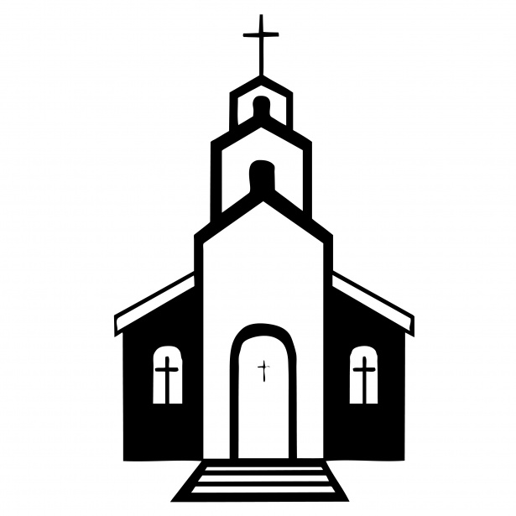
BEFORE THE SERVICE
- Put up the hymn numbers
- Turn off the fan in the sanctuary
- Light the candles on the altar
- Turn on the Lectern Light
- Fold the bulletins
- Hand out the bulletins
- Ring the Bells (Begin ringing the bells 5 minutes before the service. Let them ring between 15 and 20 times)
- Take the offering plate to the altar at the time of the offering
- Count the number of people in church.

AFTER THE SERVICE
- Check the number who have joined us online and write it on the calendar provided on the bulletin board.
- Extinguish the candles on the altar
- Put left over bulletins in the recycling bin in the cloak room
- Check the pews for any garbage


Offering Envelopes:

We kindly ask that you please complete the date, name and address portions of each offering envelope used. This is a CRA requirement for all charitable donations. This also helps to make the Sunday morning count run smoothly.

Please also note that all cheques must be made payable to Trinity Lutheran Church. It is not necessary and adds confusion when the word 'Starbuck' is added to this line.
We are deeply grateful for your continued and generous support of the work and ministry of Trinity Lutheran Church.

Treasurer Report:

Income has decreased this month but overall, it remains slightly above budget. Expenses are still significantly lower than budgeted and while the Technology (Projector project) not yet been expensed, it looks promising that overall expenses will remain well below budget estimates.
 | Jan-Sept 2026 | YTD Budget
Total Income | $109,083 | $105,954
Total Expense | $161,675 | $182,515
Net Income | - $52,592 | - $76,561
November Cleaning Schedule:

October 26- November 1 Ed & Jane R.
November 2 - 8 Loren & Janine H.
November 9 - 15 Sandra A.
November 16 - 22 Collin & Tammy S.
November 23 – 29 Doug & Joyce L.

Readings for November 2026:

November 1, 2026 All Saints Sunday
First Reading Revelation 7:9-17
Psalm Psalm 34:1-10, 22
Second Reading 1 John 3:1-3
Gospel Reading Matthew 5:1-12

November 8, 2026 24th Sunday after Pentecost
First Reading Amos 5:18-24
Psalm Psalm 70
Second Reading 1 Thessalonians 4:13-18
Gospel Reading Matthew 25:1-13

November 15, 2026 25th Sunday after Pentecost
First Reading Zephaniah 1:7, 12-18
Psalm Psalm 90:1-8 [9-11] 12
Second Reading 1 Thessalonians 5:1-11
Gospel Reading Matthew 25:14-30

November 22, 2026 Christ the King Sunday
First Reading Ezekiel 34:11-16, 20-24
Psalm Psalm 95:1-7a
Second Reading Ephesians 1:15-23
Gospel Reading Matthew 25:31-46

November 29, 2026 First Sunday of Advent
First Reading Isaiah 64:1-9
Psalm Psalm 80:1-7, 17-19
Second Reading 1 Corinthians 1:3-9
Gospel Reading Mark 13:24-37

One kind word can change someone’s entire day!
Martin, the Missionary Church Mouse

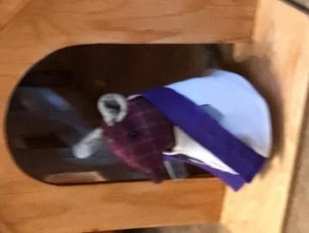



All Saints Sunday:

Each November 1st, we remember all those individuals who have been received back into the loving arms of our Creator God. November 1 is All Saints Day. We Lutherans usually recognize it on the Sunday after Reformation. The Bible teaches us that we are all small -‘s’- saints. God calls a "saint" anyone who trusts in Christ alone for salvation.
The Christian festival of All Saints Day comes from a conviction that there is a spiritual connection between those in Heaven and those on Earth. In our Lutheran tradition, this day honors all those who have passed on to the Kingdom of Heaven. It gives God earnest gratitude for the lives and deaths of all God’s people, remembering those who were well-known and those who were not known, alike.
On All Saints Sunday, November 1, 2026, we will remember all of our relatives and friends who have gone to be with Jesus in this past year. Here at Trinity, we remember the following individuals with the tolling of a bell.

Names of those who Died Date of Death
David Orville Rasmussen November 18, 2025
Shirley Agnes Rasmussen December 2, 2025
Gordon Palmer Hendrickson December 6, 2025
Gary James Rasmussen March 8, 2026
Orville Alan Olson March 30, 2026
Alexander Harold Ross August 16, 2026

In addition to those who passed away, we also remember those who were born, baptized and who made public Affirmation of their faith (Confirmed), with the tolling of a bell.

Birth Date of Birth
Norah Elizabeth Surgenor September 15, 2026

Baptism Date of Baptism
Enzo Michael Fajardo December 14, 2025
Charley Rae M. Thornson April 12, 2026
Sophie Ella Jackson October 4, 2026

Confirmation Date of Confirmation
Sophie Ella Jackson October 4, 2026



TLC Book Club:

The next TLC book club meeting will be on Tuesday, December 1st at 1:30 pm at Susan Burn’s. The book we will be reading is Theo of Golden by Allen Levi. If you are interested in attending, please call Pastor Debra at the church (204) 735-2503, or on her cell phone at (204) 807-1709.

Church Cleaning:


The church council is recommending that the costs of cleaning the main floor of the church once a month by a local cleaner be included in the 2027 budget. The calendar for volunteer cleaning will be revised in late December to adjust the schedule slightly. If you have any comments or concerns please let a member of the property committee know.

Ben Zinn, Grant Olson, Stuart Janke

November Youth Event:


The next youth event will take place November 1st from 4:00-6:00 pm at the church. Please let Brianna and Shayna know if your youth can make it so they can plan accordingly!

